abundance (RBDD production plot)

On SacPAS – Red Bluff Juvenile Passage Estimates (Red Bluff Daily Graphy with Biweekly)

survival (STARS plots) - Chase (this is a surrogate for steelhead)

* Same as the plots for winter run (Figure 2)
* Diagram

  Description automatically generated

minimization ((1) bar plots of totals (wild and hatchery), (2) annual cumulative loss by period and water year type)

(1)

(2)

minimization (loss)

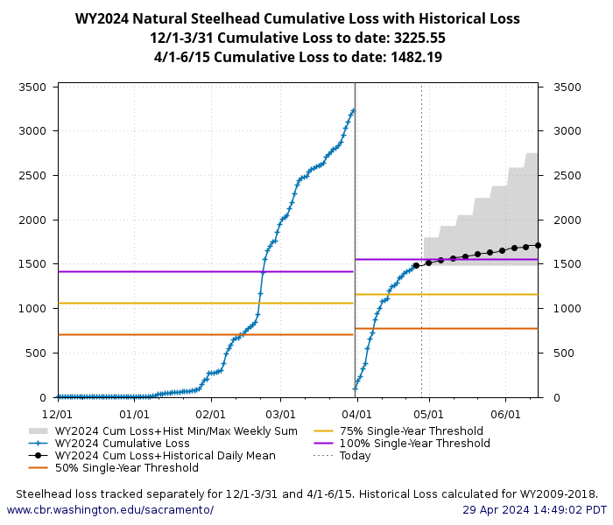

minimization (% of hatchery fish loss)

|  |  |  |  |  |
| --- | --- | --- | --- | --- |
| BroodYear | Total Hatchery Steelhead Release Number (BY) | Loss of clipped steelhead at the facilities (WY) | % Total Hatchery Release Number Lost to the Facilities | WaterYear |
| 2016 | 1,019,501 | 164.29 | 0.016 | 2017 |
| 2017 | 811,379 | 2,462.90 | 0.304 | 2018 |
| 2018 | 1,264,939 | 5,777.70 | 0.457 | 2019 |
| 2019 | 1,084,899 | 659.44 | 0.061 | 2020 |
| 2020 | 1,853,751 | 341.69 | 0.018 | 2021 |
| 2021 | 1,676,701 | 639.79 | 0.038 | 2022 |
| 2022 | 1,623,483 | 3,650.30 | 0.225 | 2023 |
| 2023 | 1,592,998 | 2,576.29 | 0.162 | 2024 |

minimization (daily loss and daily pumping rates)

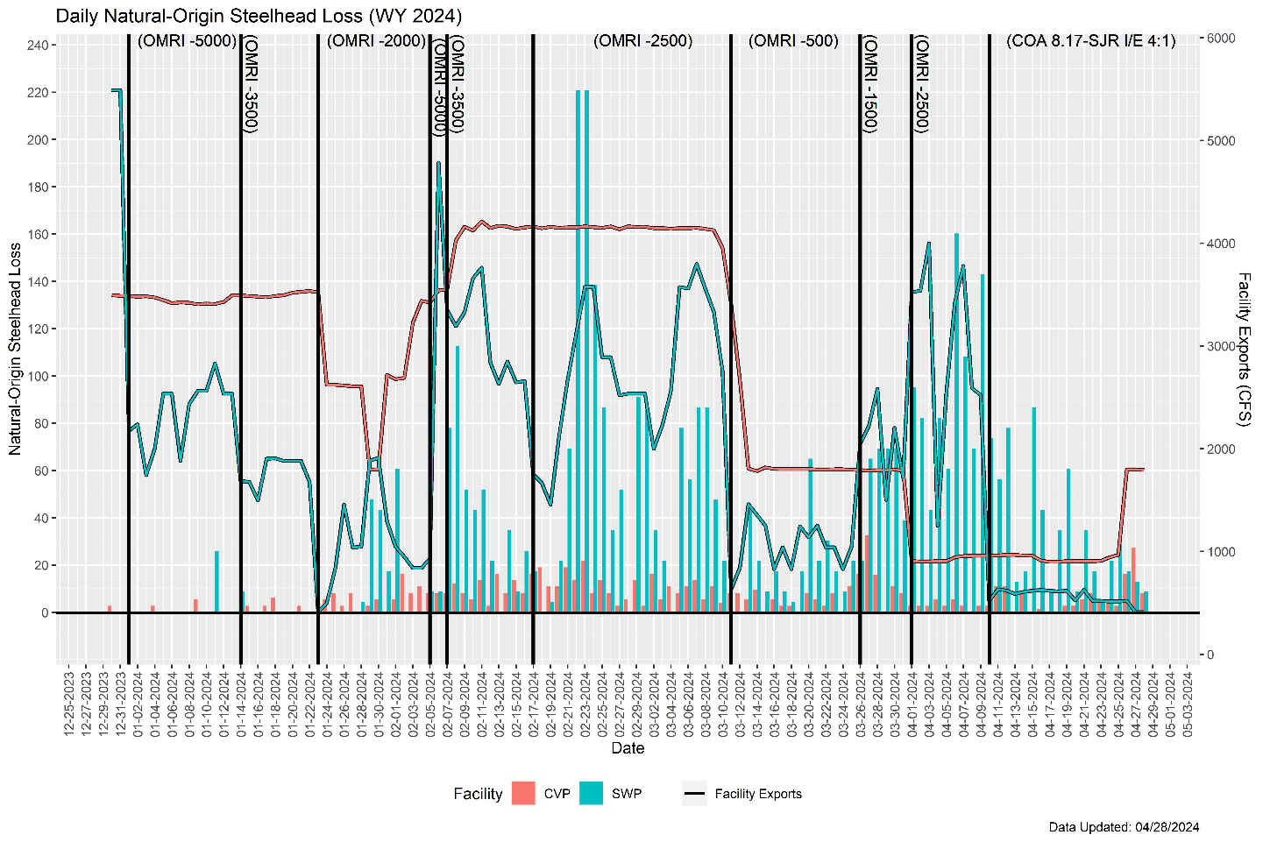

minimization (Tillotson output- predicted loss)- Chase

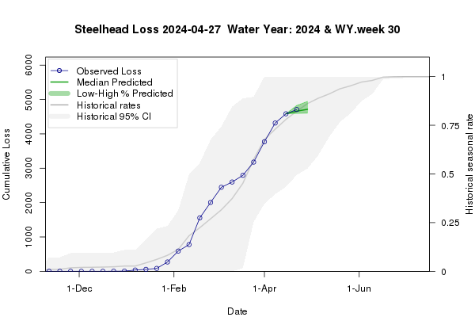

|  |  |  |  |  |  |  |  |
| --- | --- | --- | --- | --- | --- | --- | --- |
| **Natural Origin Steelhead** | | | | | | | |
| **OMR** | **Exports** | **San Joaquin Flow** | **Sacramento Flow** | **25th Percentile Weekly Loss** | **Median Weekly Loss** | **75th Percentile Weekly Loss** | **Median Daily Loss** |
| 481 | 1570 | 4938 | 24037 | 25.98 | 57.40 | 116.95 | 8.20 |
| 0 | 2100 | 4938 | 24037 | 25.98 | 73.61 | 130.21 | 10.52 |
| -500 | 2650 | 4938 | 24037 | 45.27 | 112.08 | 171.27 | 16.01 |
| -1000 | 3200 | 4938 | 24037 | 77.44 | 163.98 | 198.18 | 23.43 |
| -1500 | 3750 | 4938 | 24037 | 81.95 | 144.72 | 198.18 | 20.67 |
| -2000 | 4300 | 4938 | 24037 | 49.63 | 129.90 | 198.18 | 18.56 |
| -2500 | 4850 | 4938 | 24037 | 54.17 | 129.90 | 198.18 | 18.56 |
| -3000 | 5400 | 4938 | 24037 | 34.14 | 129.90 | 198.18 | 18.56 |
| -3500 | 5950 | 4938 | 24037 | 34.52 | 129.90 | 198.18 | 18.56 |
| -4000 | 6500 | 4938 | 24037 | 28.70 | 132.55 | 198.68 | 18.94 |
| -4500 | 7000 | 4938 | 24037 | 22.76 | 122.50 | 198.18 | 17.50 |
| -5000 | 7600 | 4938 | 24037 | 19.36 | 134.56 | 216.00 | 19.22 |
| -5500 | 8100 | 4938 | 24037 | 14.11 | 133.23 | 216.00 | 19.03 |
| -6000 | 8700 | 4938 | 24037 | 9.34 | 132.62 | 216.00 | 18.95 |
| -6500 | 9200 | 4938 | 24037 | 9.34 | 134.45 | 216.00 | 19.21 |

Weekly OMR, exports, flow, predictions for loss from Tillotson, actual loss – check in with Chase